Carti Hotel Management System

Use-Case-Realization Specification: Book Rooms

Version <1.0>

Revision History

|  |  |  |  |
| --- | --- | --- | --- |
| **Date** | **Version** | **Description** | **Author** |
| <20/11/2024> | <1.0 > | <Final Version > | <Nguyen Giang Minh> |
|  |  |  |  |
|  |  |  |  |
|  |  |  |  |

Table of Contents

1. Introduction 4

1.1 Purpose 4

1.2 Scope 4

1.3 Definitions, Acronyms, and Abbreviations 4

1.4 References 4

1.5 Overview 4

2. Flow of Events—Design 4

3. Derived Requirements 6

Use-Case-Realization Specification: Book Rooms

# Introduction

## Purpose

This document details the collaborating entities involved in implementing the "Book Rooms" use case within the design model of the Carti Hotel Management System project.

## Scope

This document applies to the Carti Hotel Management System which will be developed by our development team.

## Definitions, Acronyms, and Abbreviations

None.

## References

None.

## Overview

The subsequent section provides a comprehensive overview of the use case design, covering the flow of events through class diagram and sequence diagram, along with concise explanations for clarity. It also highlights the derived requirements critical for ensuring the use case's successful implementation and functionality.

# Flow of Events—Design

The diagrams below illustrate the required classes and the collaborative sequence for implementing the "Book Rooms" use case.

On the main page, the customer clicks the “Book Now” button to access the Booking Page. Here, they provide details such as check-in and check-out dates, the number of guests, and any promo code to initiate the booking process. After clicking the “ Search Room” button with entered valid information, the system redirects to the Room Page, where the Room Controller displays available room options.

The customer can then select a specific room. The Room Controller retrieves and displays details of the selected room.

After reviewing the room details, the customer clicks the “Book & Proceed” button to proceed to a page for validating their information.

If the information is valid, the Room Controller updates the customer and booking records, redirects to the Success Booking page, and sends a confirmation message. If the information is invalid, an error message is displayed.

## Sequence diagram

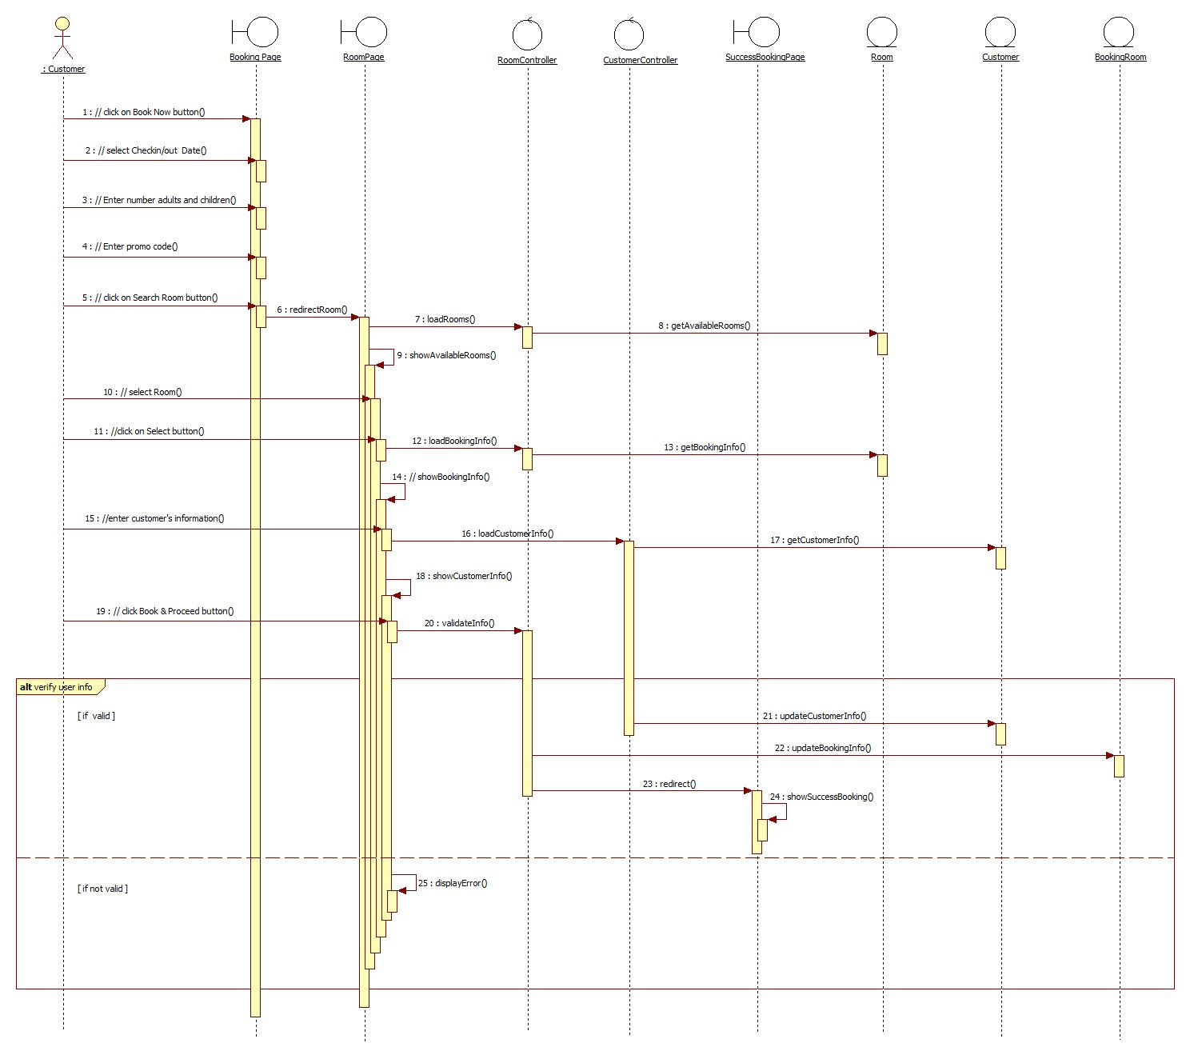

## Class diagram

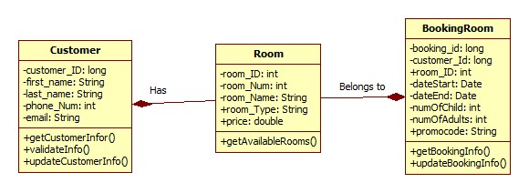

# Derived Requirements

None.